Aceh, Marechaussee Brigades on photographs
Picture base for the purpose of my article “Marechaussee Battle Song”
Dirk Teeuwen MSc, Holland

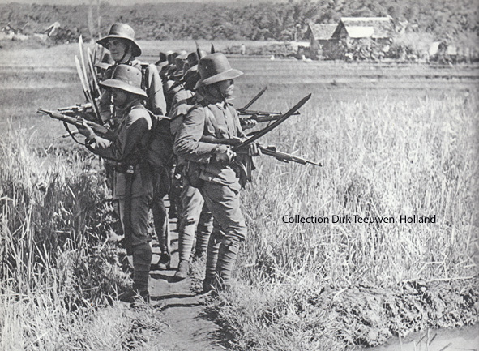
1. Ready with sable (right) and gun (left hand). From> Schuh, Gotthard: Eilanden der Goden; Amsterdam 1943, p. 62

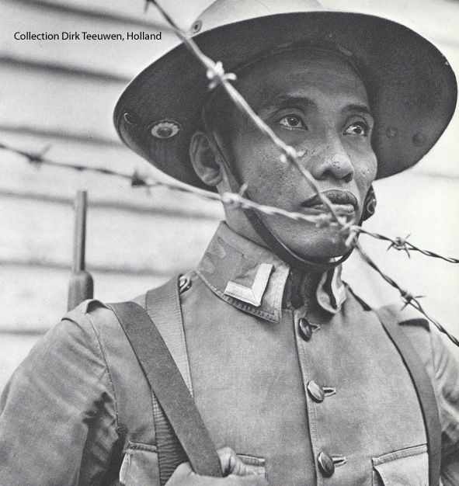
2. From> Schuh, Gotthard: Eilanden der Goden; Amsterdam 1943, p. 103

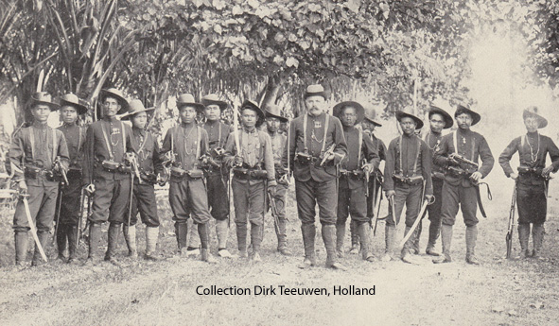
3. The Marechaussee Brigade Frank near Sigli, Aceh in 1908. Brigade Commander Frank, the European in the centre, was decorated in 1909. He received the Dutch MWO, the Militaire Willemsorde (Military Order of William I, a very high decoration). From> Croo, M. H. du: Marechaussee in Atjeh; Maastricht Holland 1943, p. 126
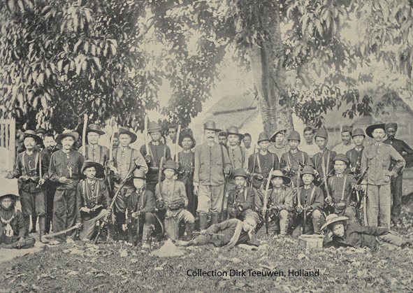
4. The Marechaussee Brigade Döring (the second Division at Kampung Jeuram, Aceh; Sergeant Döring with moustache stands in the centre). This Brigade brought Teuku Keumangan and his 12 panglima’s (community chiefs) in captive to Meulaboh (Aceh) on suspicion of conspiracy against the Dutch East-Indian government.

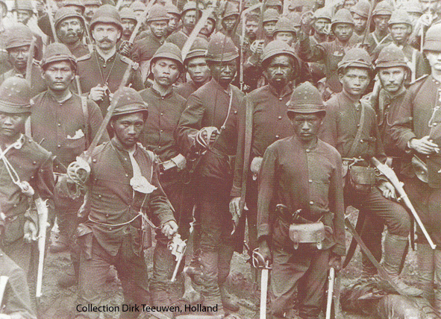
5. Shortly after the battle (Marechaussee Brigade near Sigli, Aceh 1902). Detail from a photo in > Pusat Dokumentasi Aceh: Perang colonial Belanda di Aceh; Banda Aceh 1977, p. 176

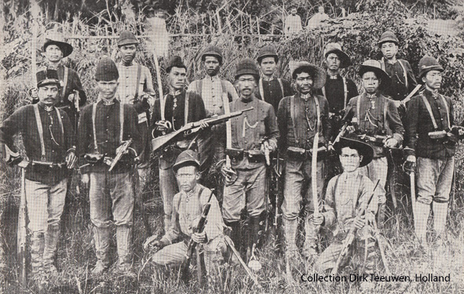
6. One of the oldest Brigades in Aceh, 1891. Their uniforms are still different, which changed very soon. The men are Indonesian natives. Commanders (sergeants, corporals mostly) as well. From> Zentgraaff, H. C.: Atjeh; Batavia (Jakarta) 1931, p. 131

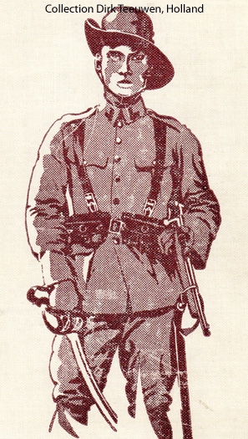
7. European Marechaussee
From> Brasser, J. C.: Soldatenleven in de Indische wildernis; Zutphen Holland 1930, front page. Drawing by Pol Dam.

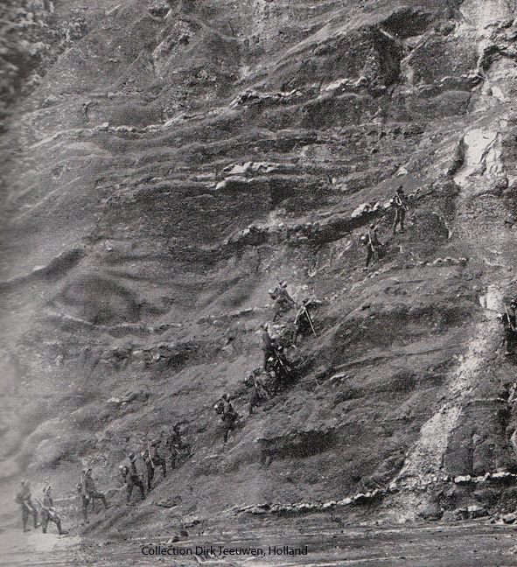
8. Marechaussee Brigade on open terrain; Aceh circa 1915
From> Brasser, J. C.: Soldatenleven in de Indische wildernis; Zutphen Holland 1930, p. 12

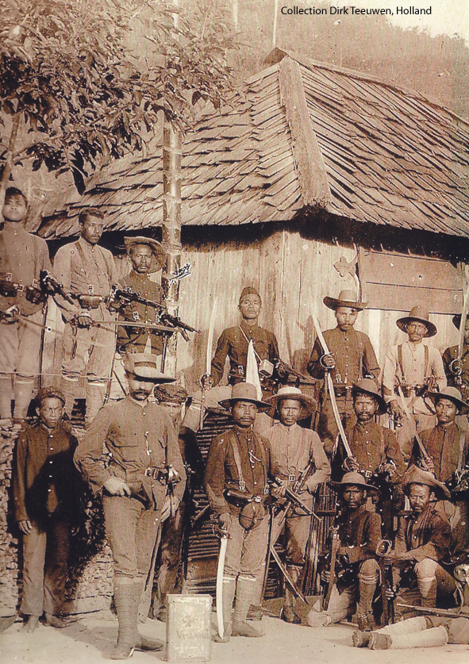
9. Without words. Ok, Aceh circa 1890. But however, besides that, I don’t know where this (wonderful) picture comes from. Not the faintest idea.

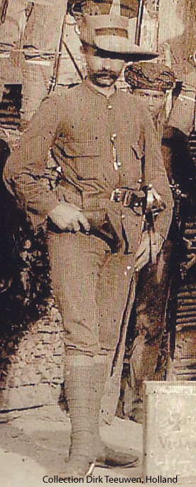
10. Detail from picture 9

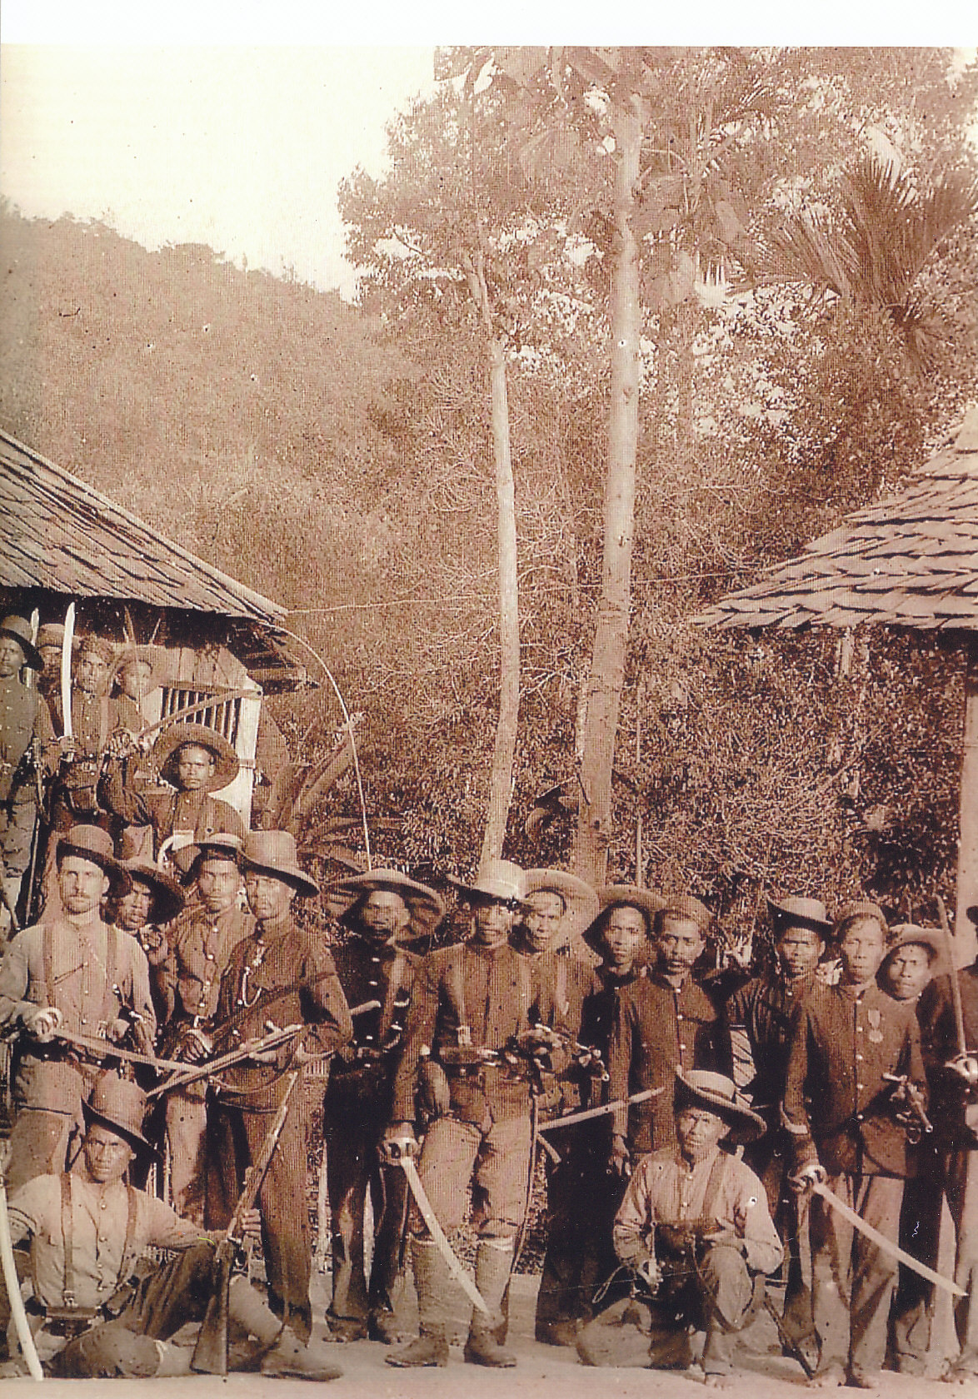
11. Without words. Ok, Aceh circa 1890. But however, besides that, I don’t know where this (wonderful) picture comes from. Not the faintest idea.

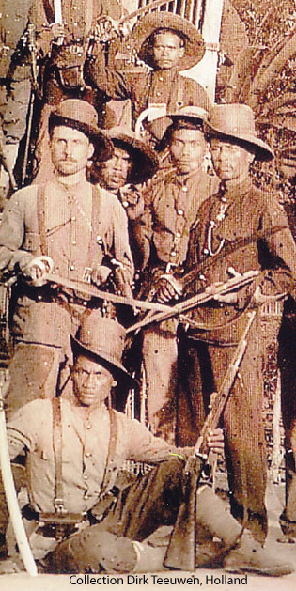
12. Detail from picture 11

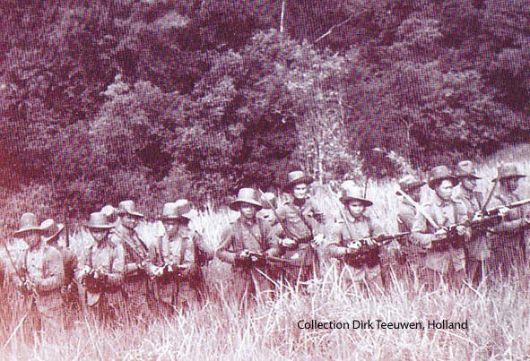
13. Marechaussee Brigade, patrol in the jungle; Aceh circa 1915
From> Brasser, J. C.: Soldatenleven in de Indische wildernis; Zutphen Holland 1930, p. 12

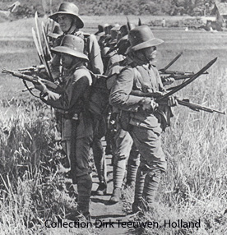
The end

